How to create dispatch
This is our Asian log sheet (sample)

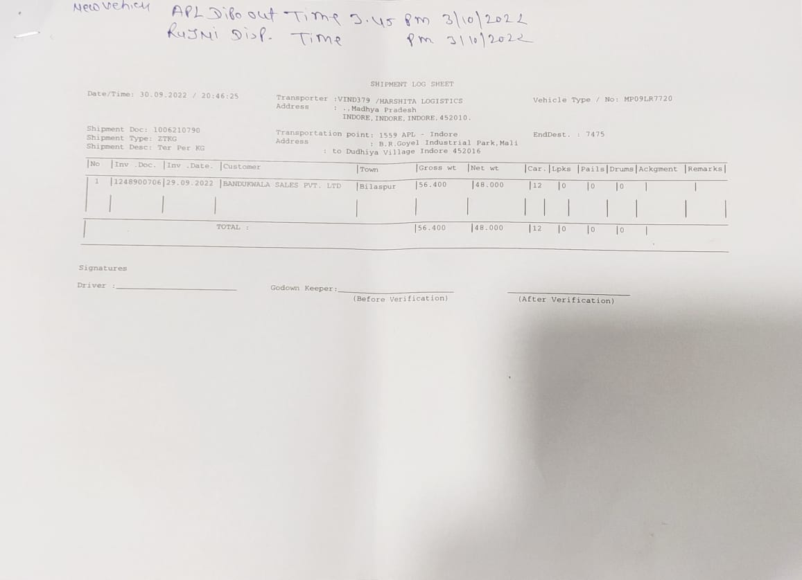

Below are the details mention that how you can create dispatch from this log sheet

Create Trip
1. Gate pass No- In this you should mention log sheet number or get pass number in this.

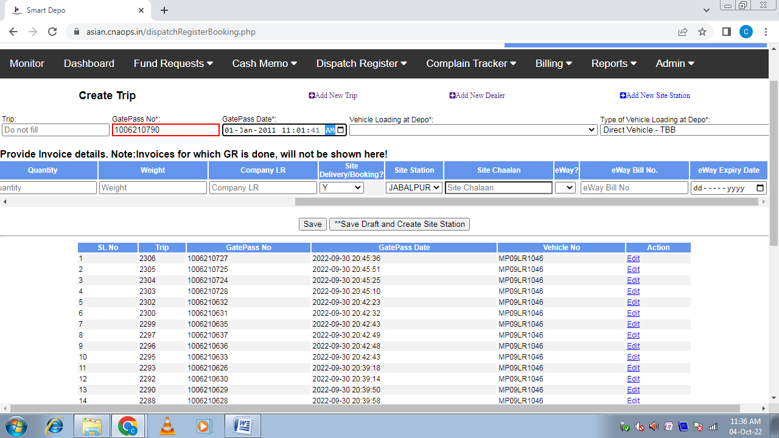

2. Gate Pass Date- Actual Gate Pass Date and Time.

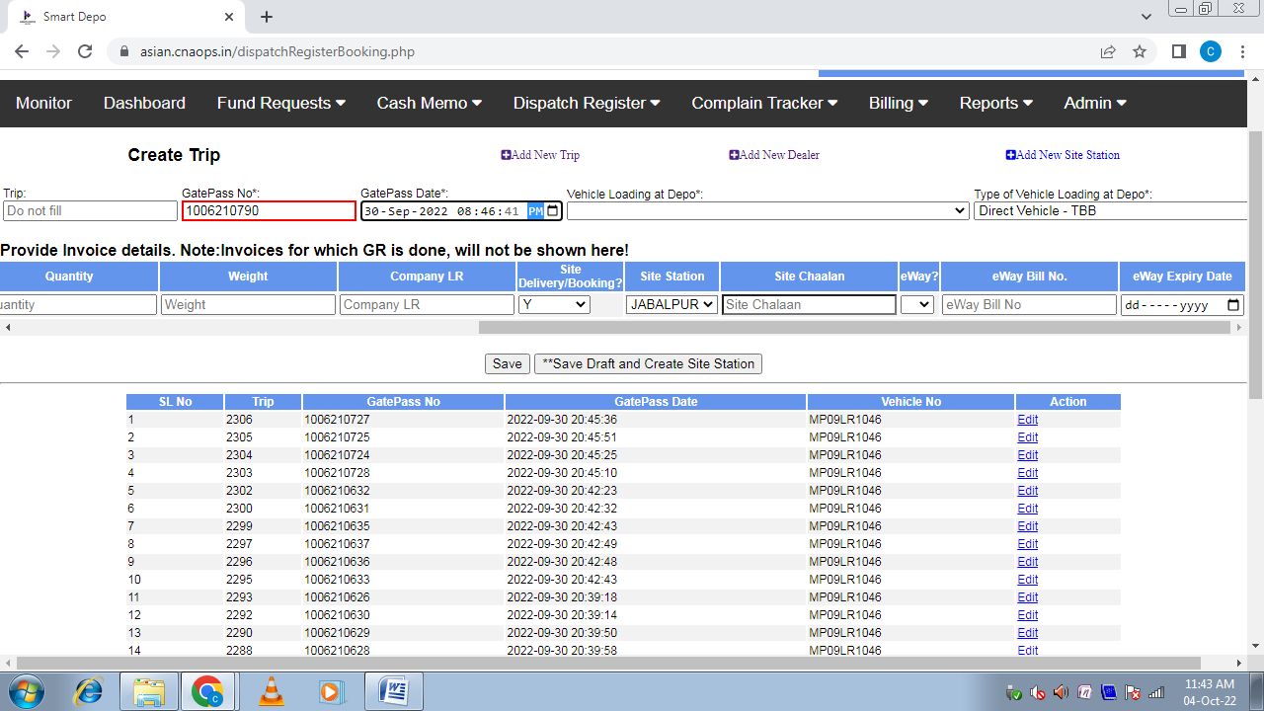

3. Vehicle Loading at Depo- Mention vehicle number.

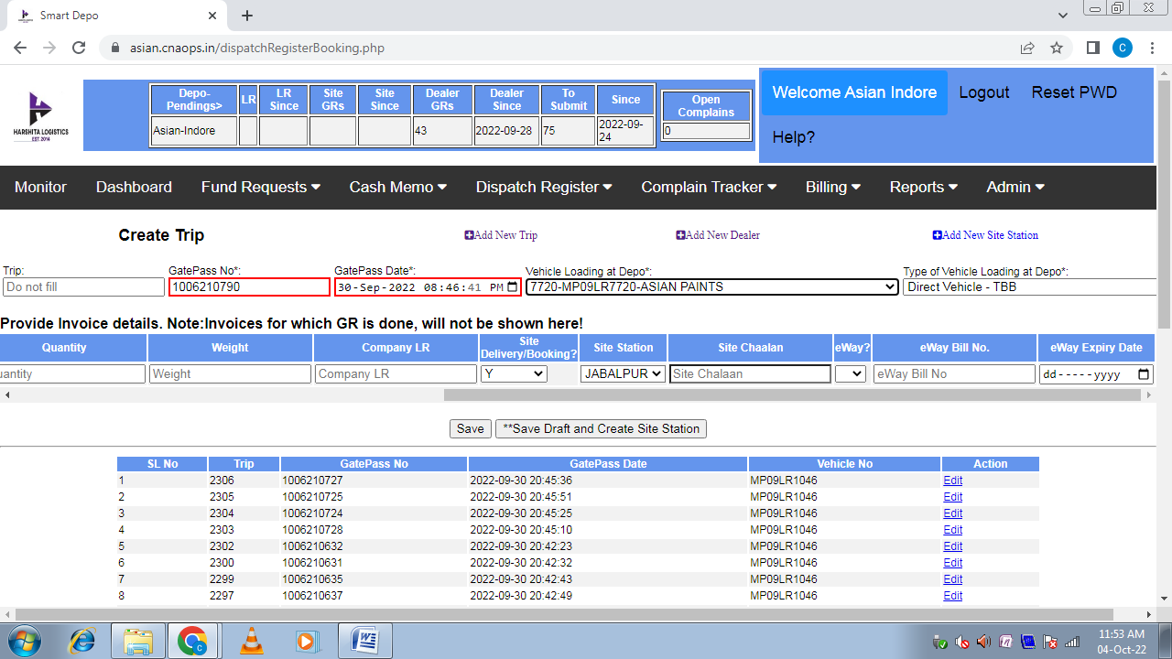

4. Type of Vehicle Loading at Depo- Mention vehicle type (tbb, paid or any other).

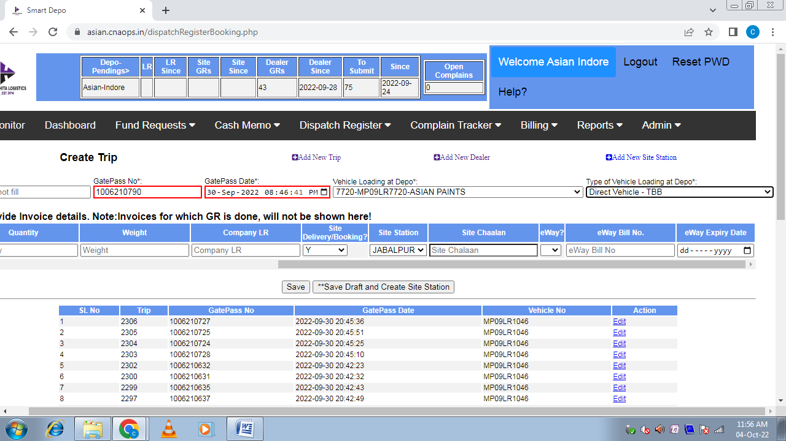

Provide Invoice details. Note: Invoices for which GR is done will not be shown here!

1. Invoice No: - Mention Invoice Number

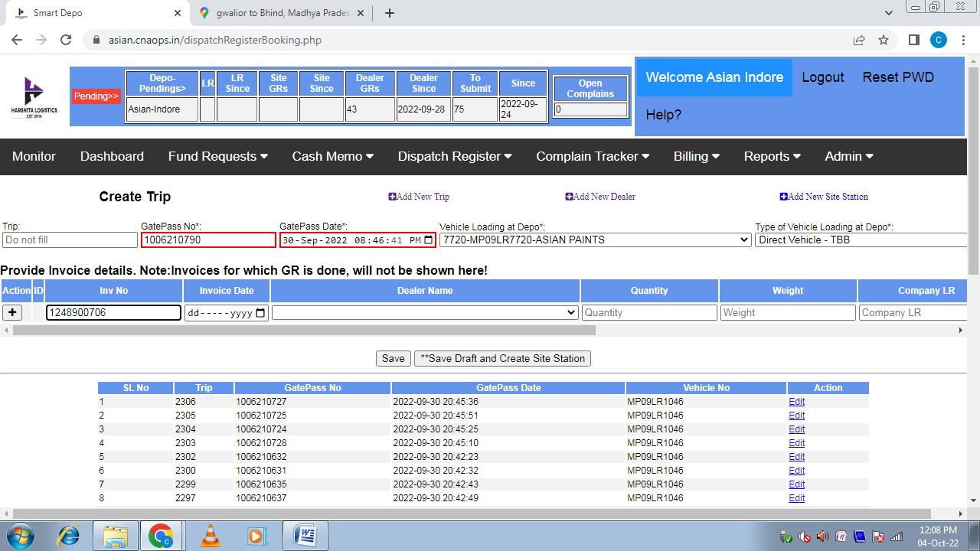

2. Invoice Date: - Mention Invoice Date

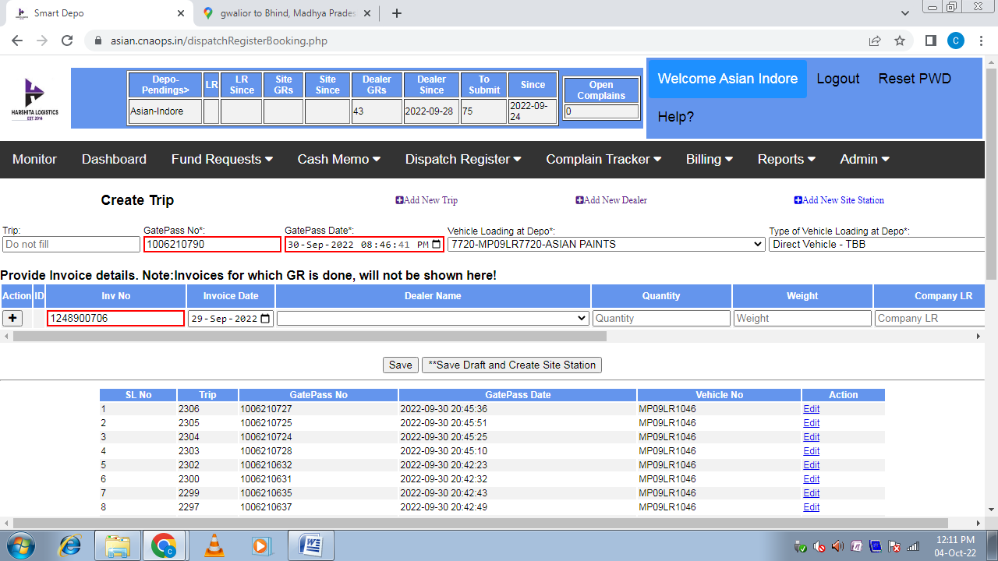

3. Dealer Name- Mention Dealer Name

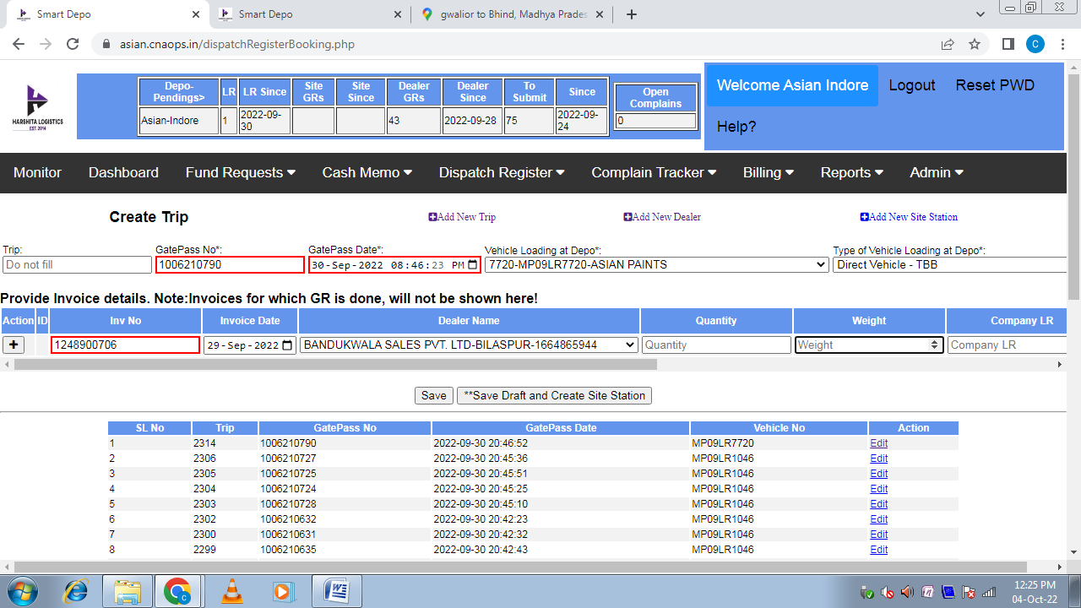

4. Qty- Mention Qty

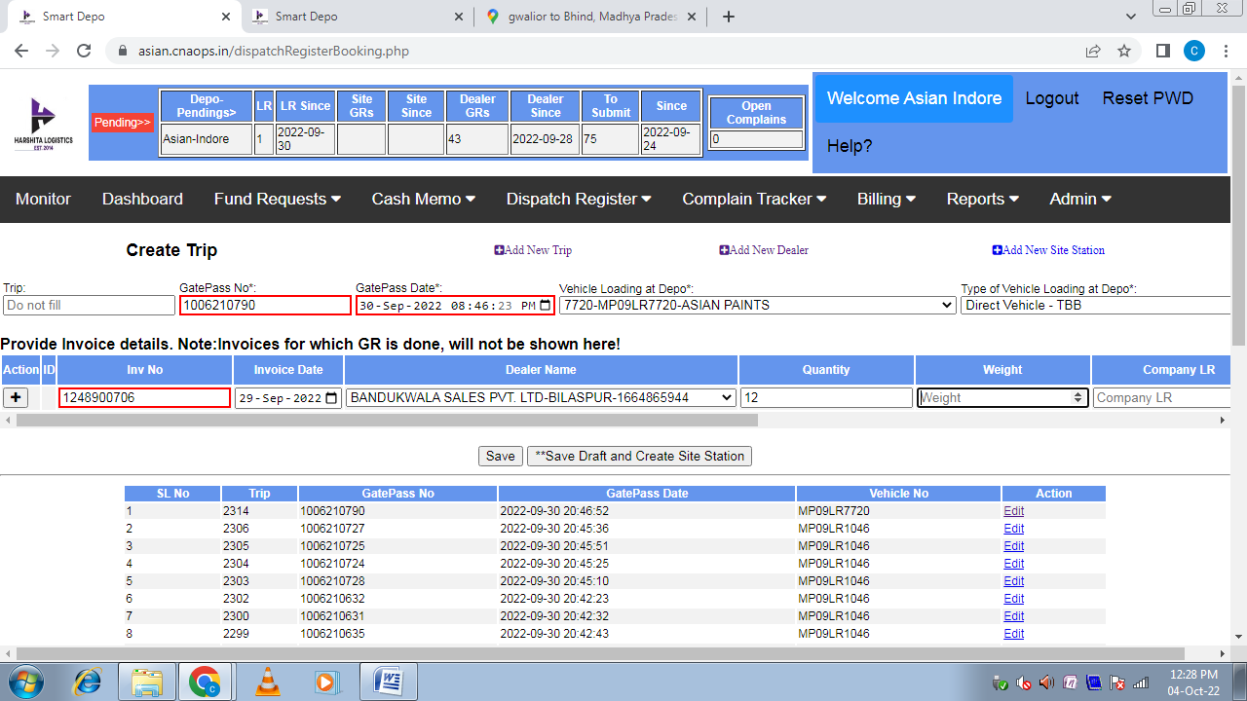

5. Weight- Mention Weight

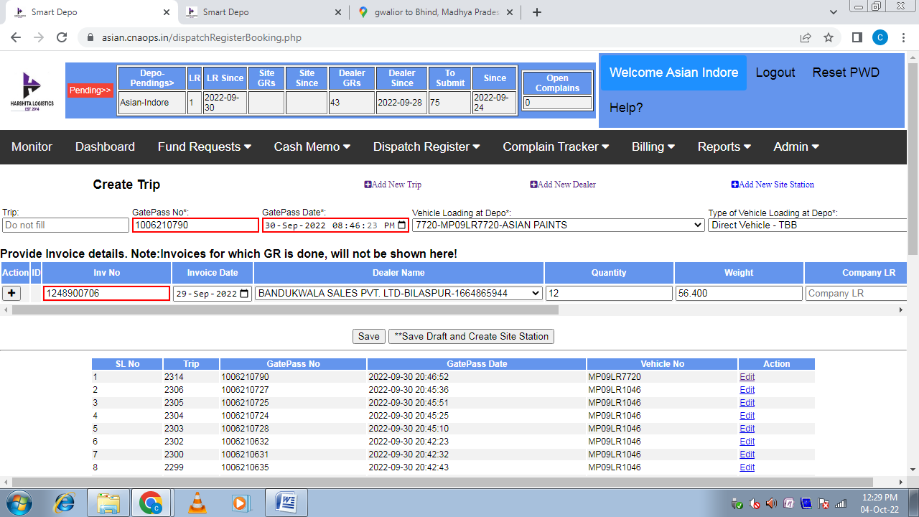

6. Company LR: - Mention our Company LR Number

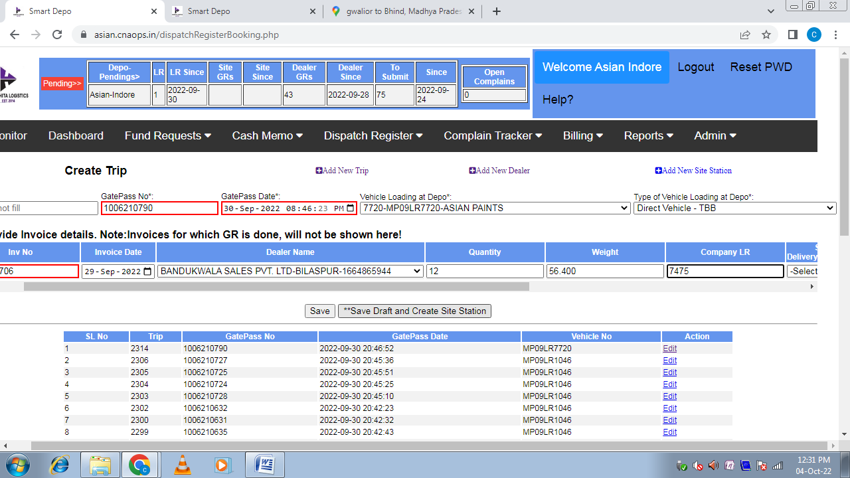

7. Site Delivery/Booking?
(i) N- If material is delivered at dealer’s location
(ii)Y- If material is delivered at dealer’s site location (in that case dealer provide us challan)
(iii)Booking- If material is delivered at Depo
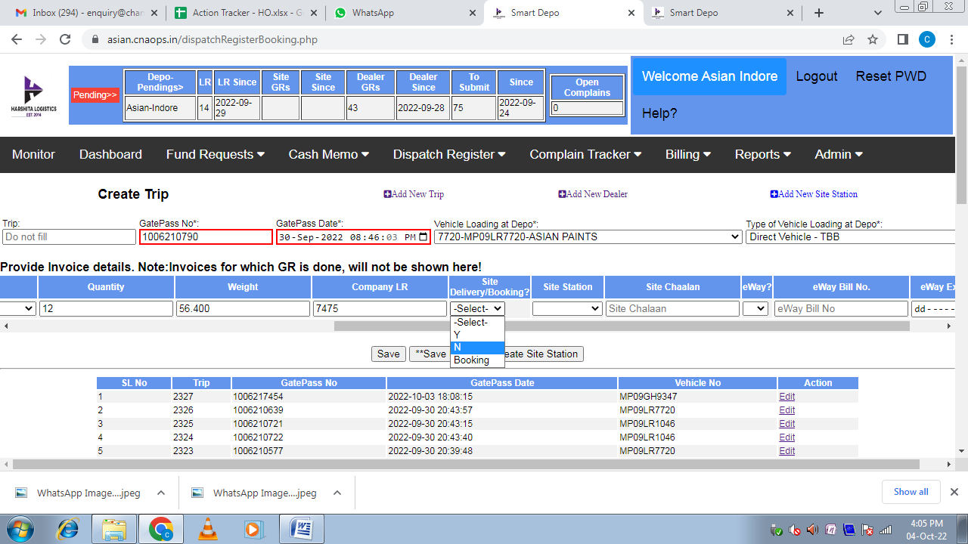
NOTE: IN THIS LOG SHEET MATERIAL IS DELIVERD AT DEALER’S ADDRESS SO WE SELECTING N IN SITE DELIVERY/BOOKING SECTION.

8. Site Station: - If material is delivered at dealer site in that condition mention site station name.
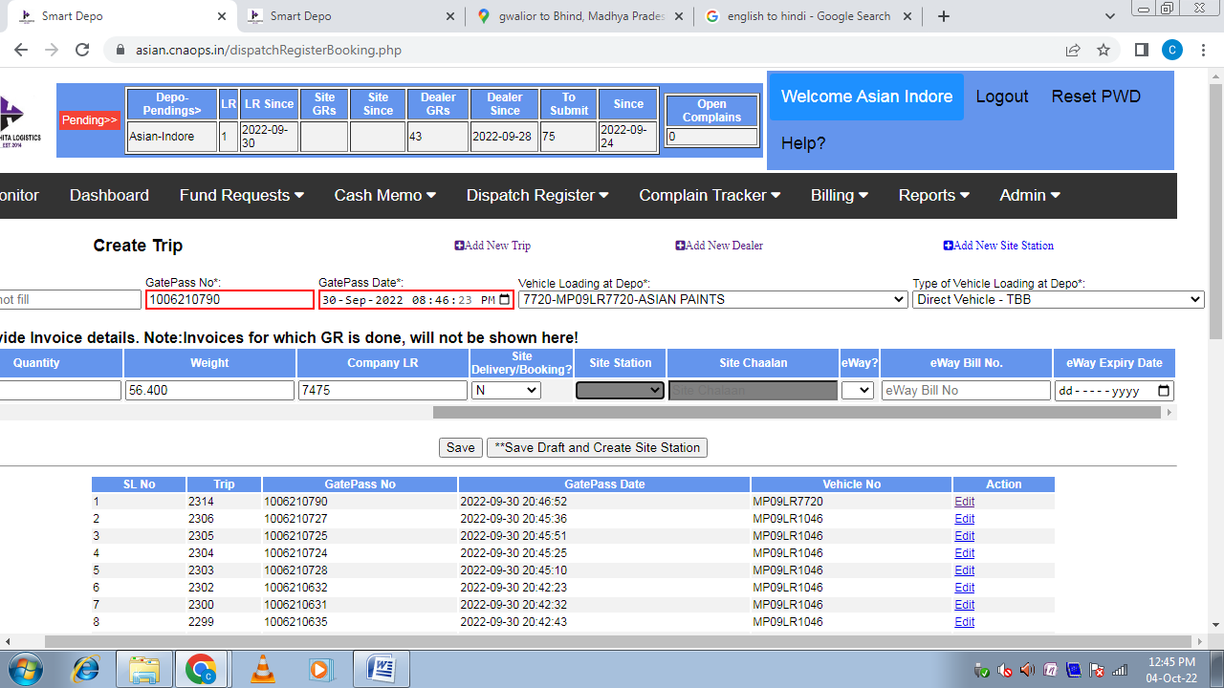NOTE: IN THIS LOG SHEET MATERIAL IS NOT DELIVERD AT DEALER’S SITE SO WHEN YOU PRESS TAB KEY AFTER SELECT N IN SITE DELIVERY/ BOOING SECTION THEN SITE STATION SHADAED BLACK.
9. Site Chalaan: - In site station case mention chalaan number

NOTE: IN THIS LOG SHEET MATERIAL IS NOT DELIVERD AT DEALER SITE SO WHEN YOU PRESS TAB KEY AFTER SELECT N IN SITE DELIVERY/ BOOING SECTION THEN SITE STATION SHADAED BLACK.

10. e-Way: - If e-Way bill is available then select Y or if e-Way bill is not available then select N.

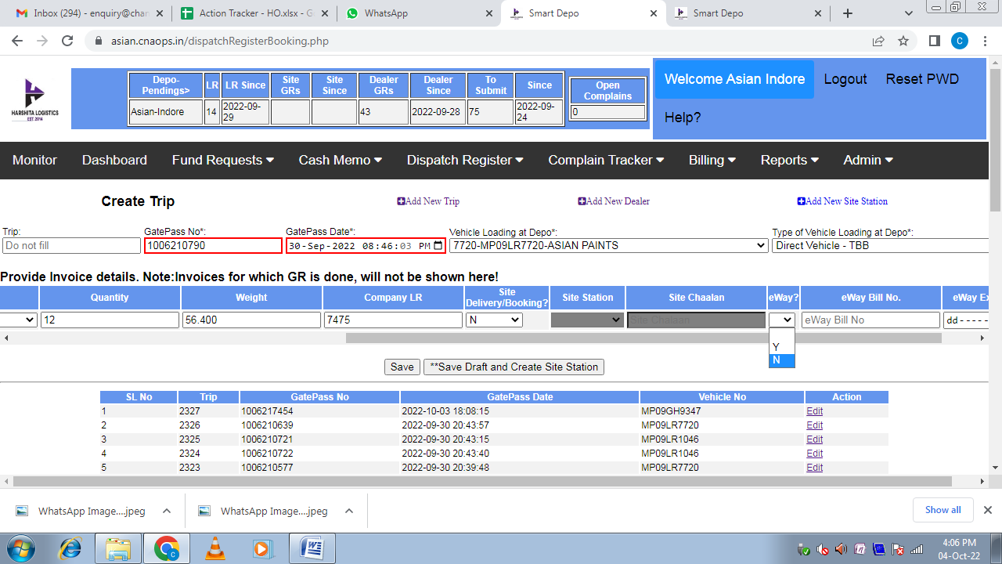
NOTE: IN THIS LOG SHEET E-WAY BILL IS NOT CREATED SO WE SELECT N IN E-WAY BILL SECTION.

11 e-Way Bill Number: - If e-way bill is available then mention e-Way bill number

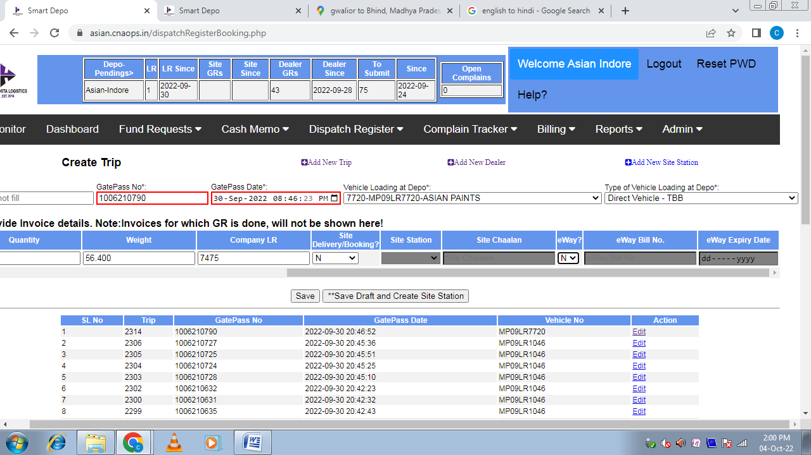NOTE: IN THIS LOG SHEET e-WAY BILL IS NOT AVAILABLE. SO WHEN WE PRESS TAB KEY AFTER SELECT N IN e-WAY SECTION THEN e-WAY BILL NO.SHADAED BLACK.

12 e-Way Expiry Date: - If e-way bill is available then mention e-Way bill expiry date

NOTE: IN THIS LOG SHEET e-WAY BILL IS NOT AVAILABLE SO WHEN WE PRESS TAB KEY AFTER SELECT N IN e-WAY SECTION THEN e-WAY EXPIERY DATE SHADAED BLACK.

13 Save: -After create dispatch save this working process.

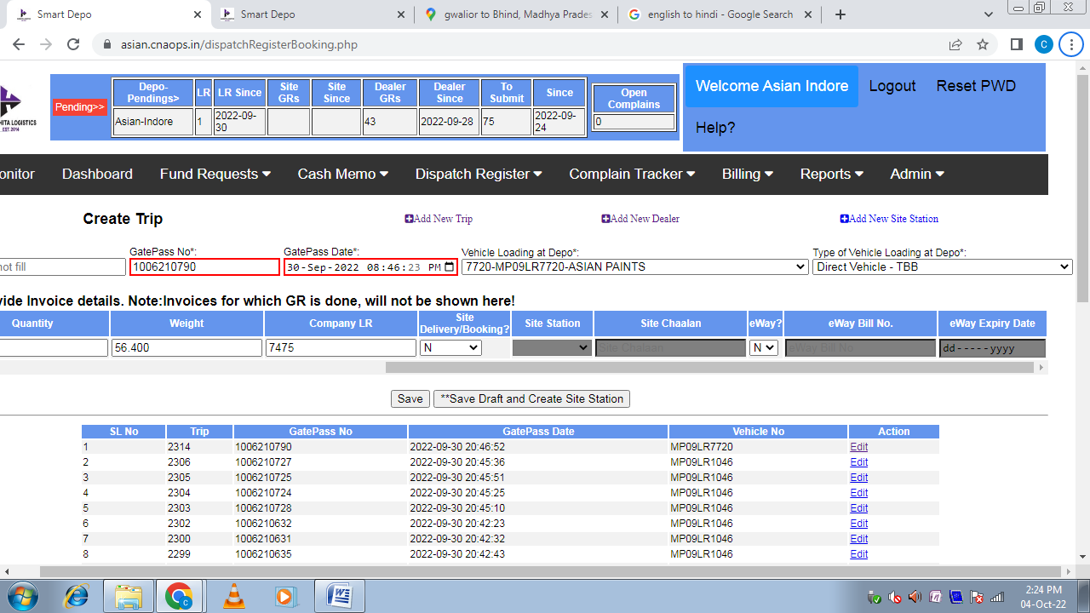

HERE WE COMPLITE OUR DISPATCH CREATES PROCESS.

